THIS DOCUMENT IS FOR INFORMATIONAL PURPOSES ONLY. IT IS NOT A COMMITMENT TO DELIVER AND MAY NOT BE INCORPORATED INTO ANY CONTRACT.
Document Revision History
Revision Date By Remarks
A1 | 2007-09-04 | JoMuUs | Created
1 Introduction 3
1.1 Document Scope 3
1.2 Terminology Clarification 3
2 Configure to Order 3
2.1 Overview 3
2.2 Defining Configurable Parts 4
2.2.1 Define Configuration Characteristics 4
2.2.2 Define Configuration Family 5
2.2.3 Configured Parts (Base Items) 6
2.2.4 Define Product Specification Revisions 6
2.3 Back Office Configuration Rules 7
2.3.1 Overview 7
2.3.2 Conditions and Actions in Structures and Routings 8
2.3.3 Configuration Formulas 11
2.3.4 Combination Tables 11
2.4 Configurations in Customer Order 12
2.4.1 General 12
2.4.2 Configured Quotation 12
2.4.3 Interim Order from Quotation 12
2.4.4 Convert Quote to Order 13
2.4.5 Changing Quote After Converted to Order 13
2.4.6 Configured Order 13
2.4.7 Interim Order from Customer Order 14
2.4.8 Release Customer Order Line 14
2.5 Configurations in Interim Order Structure 16
2.5.1 General 16
2.5.2 Interim Demand Head 16
2.5.3 Interim Order Supply 16
2.5.4 Interim Order Demand 17
2.6 Configurations in DOP 17
2.6.1 General 17
2.6.2 Configured DOP Header - Basic 18
2.6.3 Configured DOP Header – No Interim Order 18
2.6.4 Configured DOP Header – With Interim Order 19
2.6.5 Configured DOP Order - General 20
2.6.6 Configured DOP Order – Pegged Orders 20
2.6.7 Configured DOP Order - Netting 20
2.7 Configurations in Shop Order 21
2.7.1 General 21
2.7.2 Configured Shop Requisition 21
2.7.3 Configured Shop Order 21
2.7.4 Configured Shop Material Allocations 23
2.7.5 Configured Shop Order Split 23
2.7.6 Configured Shop Order Merge 23
2.8 Configurations in Purchasing 24
2.8.1 General 24
2.8.2 Configured Purchase Requisition 24
2.8.3 Convert Configured Purchase Requisition to Purchase Order 24
2.8.4 Convert Configured Purchase Requisition to Request for Quote 24
2.8.5 Configured Purchase Order 24
2.8.6 Receive Configured Purchase Order 24
3 CTO Design Topics 25
3.1 Creating Configurations and Uniqueness in Configuration IDs 25

Introduction

Document Scope
This document seeks to provide a rapid overview of the scope and key concepts of Configure to Order functionality as well as discuss key and persistent topics related to the design or capabilities of the application. The intended audience is IFS internal analysts, developers, or support personnel with an interest in the background to the CTO solution.
Note: The Sales Configurator application is not discussed here to any depth.

Terminology Clarification
The term “Configurator” or “The Configurator” in reference to the CTO application is a confusing and often-misused reference reflecting a lack of clarity regarding our application design. It is important to recognize IFS has two “configurator” applications:
- The Sales Configurator, the front-end and optional application providing a means of defining sales rules to indicate valid product configurations that can be sold. The Sales Configurator is the real “Configurator” application, and is comprised of the Sales Configurator Workshop application (where rules are defined) and the Sales Configurator Professional application (where sales orders and/or sales configurations are specified). As noted, this application is not required to run our CTO flows and is a formerly 3rd party acquired application (Exactium) integrated with our order entry flows.
The Sales Configurator functionality is required if users have a need to validate allowed ranges of configuration values (e.g. HEIGHT must be between X and Y) or relationships between data values (HEIGHT cannot be X if COLOR is Y).
- The Back Office Configurator, the manufacturing configuration tool allowing users to define rules for defining the proper manufacturing structure and routings for previously entered, and valid, sales configurations. The back office configuration software is required to execute the CTO manufacturing flows.

Configure to Order

Overview
The Configure to Order (CTO) application encompasses a range of features for handling configured or customized manufactured products. Support for configured products was introduced throughout the majority of the Distribution and Manufacturing application flows from sales to manufacturing, inventory through purchasing. In addition, a custom sales configurator application can optionally be utilized to assist in the demanding problem of quoting and selling configured products. The repetitive applications, including Production Schedules, Supplier and Customer Schedules, and Kanban do not support configured products. Likewise, the Engineering, Project, and Maintenance applications also do not support configured products at this time (Apps7).
To understand how the CTO application flows differ from standard application flows, it is necessary to understand the consequence of offering a configured or customized product. In short, the “standard” answer to normal business inquiries often cannot be answered without first knowing exactly the configuration of the item to be handled. Questions like:
- What is the price?
- What is the lead time?
- What is the cost?
- What components are required?
- What operations are required?
In all cases the answer to the above questions is: It depends on the configuration.
So with configured products, there is typically little hard information or activity until a customer commits to a specific desired and valid configuration. Once specified, the above answers can be addressed, but usually not before. Part numbers, in the case of CTO, represent only the “base” part or product model. With standard product flows, Part and Site is sufficient information to describe material. But with CTO a configuration must also be present to understand the real nature of the material requirement or supply.
Any time configured parts are handled in an order flow or parts-handling use case, a valid configuration must accompany the order. And as demand for a configured part leads to a chain of supplying orders, it is important that the configuration be passed from one order to another.

Defining Configurable Parts

Define Configuration Characteristics
A configuration characteristic or product feature represents an attribute later used to describe a product configuration for a base item. Sample values: LENGTH, COLOR, VOLTAGE, etc.
Product configuration characteristics are a string ID, a description, and value settings to indicate the data type used to express this characteristic. Each characteristic is identified with a data type:
- Numeric
- Alpha
And a value type as follows:
- Discrete Option – characteristic is a set of choices (e.g. Color = Red, Yellow or Blue).
- Variable Value – an infinitely variable value (e.g. Length = 21.48 or Customer Instructions = ‘For pattern info. see customer drawing).
Language-dependent descriptions for the configuration characteristic can be stored. is used for display cases where the configuration is presented in a report or other display.
Example Configuration Characteristic:
Characteristic: COLOR Description: Color of item
Data Type: Alpha Value Type: Discrete Option
Language Dependent Description Language Code:
Color of item EN English
Colore del parte SP Spanish
Discrete options are defined for the configuration characteristic. For example, the characteristic COLOR might include choices: RED, YELLOW, GREEN and BLUE. But not all colors are necessarily valid for all configured parts. All possible option values are kept here for central validation and language support. As with configuration characteristics, language dependent descriptions for discrete option choices can be stored.

Define Configuration Family
A configuration family is used to group base items sharing common product characteristics. This provides a structure for managing common parts and is a ‘template’ of configuration characteristics. A configuration family is identified by a short text name, and includes a brief description of the family. (e.g. ‘CHAIR’, ‘Chair Configuration Family (not include wheel chairs)’) as well as additional internal note text.
Each configuration family has a set of characteristics associated with the family. All base items in the family use a subset of this same set of configuration characteristics and values. Users maintain the set of characteristics associated with a product configuration family, choosing from the list of characteristics defined in the previous step.
This data represents a subset of data also maintained in Sales Configurator Workshop rules. This is the data required to help the users define the configuration entry rules (e.g. list of values, basic validations). However, the definition of a characteristic originates in the IFS application and is migrated to the Sales Configurator – characteristics are not created in Sales Configurator.
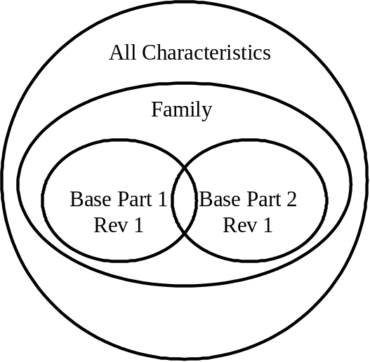
Figure 1 - Configuration Characteristics, Families, and Base Parts
Other info about family characteristics:
- Default Option Choices: If the value type for a characteristic is ‘Discrete Option’, then the individual choices can be stored for that characteristic. At the family level, these represent the default values to be copied to the base items, different choices can be enumerated for each base item.
Example Product Configuration Family:
Product Config. Family: CHAIR Description: Chair Family (not include wheel chairs)
Characteristic Description Data Type Value Type
COLOR Finish color Alpha Discrete Option
LEGLNTH Leg Length Numeric Discrete Option
FABRIC Fabric style Alpha Text
SEATHT Seat height Numeric Value Range
Characteristic: COLOR Option Value Description
RED Deep red
BLUE Ceylon blue

Configured Parts (Base Items)
Users indicate the part is ‘Configurable’ at the Part Catalog level, and must then identify the Product Configuration Family to which the item belongs.
At the time a part is created, a new Product Specification Revision is created including all of the family’s characteristics. These characteristics are optionally copied to the product specification revision of the base item, where they can be further edited: more limited discrete option value ranges (e.g. not all values in family are allowed). The data definition follows the same structure as for product configuration families described above.
Rules and restrictions for configurable parts (so far):
- Configurable parts cannot be of type ‘Expense’, ‘Purchased Raw’ or ‘Manufactured Recipe’.
- Configurable parts cannot be of MRP Order Code ‘B’, ‘C’ (order point planning), ‘O’, ‘T’ (master schedule planning parts), ‘K’ (blowthrough), ‘M’ (manuf cell – approximately ‘manually planned’), ‘N’ (next level demand).
- Configurable parts are not planned by MRP.
They can be DOP or not, depending on the BOM construction. Note that if multi-level configurations are used, DOP must be used as the production method for the part.

Define Product Specification Revisions
At the time a configured part is created, a product specification revision is created with phase in date equal to system date, and an open phase-out date. All of the currently valid characteristics for the configured part’s family are optionally copied to this first revision. You can now add any additional characteristics specific to this base item revision. If desired, you can phase out or phase in a new characteristic. This creates a new product specification revision, copying all the characteristics and their attributes (discrete options, etc.) forward to the new revision.
A revision system is introduced to help manage product characteristics for a base item as they change over time. Note this system is distinct from either Engineering Revisions or Part Revisions – it is possible that sales characteristics for a part could be altered without affecting the manufacturing rules for it. Vice versa, a manufacturing change could occur without changes to the selling characteristics – thus a separate revision system is used to manage the list of characteristics possible for a configurable part as of a certain date.
A product specification revision is defined by a version number and a phase-in/out date and optionally a description.

Product A | Revision 1 | Jan 1 2007 – Jul 20 2007 |  | Revision 2 | Jul 21 2007 –
 | COLOR | Alpha, Discrete | → | COLOR | Alpha, Discrete
 | LENGTH | Numeric, Variable | → | LENGTH | Numeric, Variable
 | HEIGHT | Numeric, Variable | → | HEIGHT | Numeric, Variable
 |  | New characteristic introduced in revision 2 | → | DEPTH | Numeric, Variable

A product specification revision also represents the equivalent of a Sales Configurator version file for a sales part. When a configurable part is created as a Sales Part, that part and all of its characteristics/options are transferred to the Sales Configurator for further sales rule development. Only the basic outline of a product’s defining sales characteristics (though not their rules) are represented here.
The date phased revision system indicates the specification revision expected to be valid for configurations created during that date range. There is no necessary relationship between this date range and the BOM date ranges. A configuration exploded through the BOM uses the normal BOM revision selection logic (either date or serial) as of the time the BOM is exploded, not related to the configuration revision. Of course some coordination is expected, but this is a manual responsibility of the user.
Once the base item characteristic/option possibilities are defined, users can work with the configured parts. For manufactured parts, the next logical step is to define back office configuration rules.

Back Office Configuration Rules

Overview
The back office configurator allow users to control the results of a configured part explosion through the manufacturing structure and routings in order to create potentially unique manufacturing orders.
The back office configurator can be considered a sort of development environment, like a limited programming tool. The application provides tools for the user to control data outputs (structures and routings) based on the input (a part configuration). Users define conditions (IF/THEN logic) and actions (commands) while working with data variables (configuration values) in functions and formulas (re-useable programs).
Back office rule definition is the tool by which users control which components, routing operations, tools and work instructions are required to manufacture various configurations. To accomplish this, a special type of manufacturing structure and routing is used. The structures and routings for configured parts are distinguished by the ability to attach ‘rules’ to the elements of the structure (i.e. components, work instructions) to indicate when they should be included, and how, if necessary, they should be modified for a particular combination of configuration characteristics.
Some concept definition to help understand back office configurator concepts:
- Configuration Specifications are the input to back office rules
- Rules – selection conditions and action execution, what they can be attached to.
- Scope of variables, configurations
- Multi-level configuration – inheritance and declaration
- Interim Orders as testing medium – evaluation logs
- Configured BOM explosion – occurs in Shop Order, DOP, Interim Order
Configured parts exclusively use Configuration Structures of the various types (Manufactured, Purchased, Recipe, etc.) This structure type is specific to configured items. Routings, on the other hand, are not specific to part type and are shared by both configured and non-configured items. The configuration rules for routings are enabled only for configured items.

Conditions and Actions in Structures and Routings
Conditions are a rule expressed in the form of a Boolean equation and attached to elements of configured structures and routings. The condition is defined in terms of data relevant to the configuration including characteristic values, quantities, constants, or the results of either configuration formulas or combination tables. Conditions indicate if the element is to be attached to the configuration’s structure or not. If a condition is true, then the item is to be included in the structure/routing and the actions are then processed. If not true, the item is not included in the structure and processing continues to the evaluate the next items.
Actions are a rule specifying processing to occur for structure and routing elements included in the configuration. Actions are defined in terms of a statement to be executed to perform some change to the data values expressed in the “base” structure or routing. For example, the Qty per Assembly for a component can be “Set” equal to a value derived based on configuration values.
Configuration rules can be attached to seven items within configuration structures and routings:
- Structures:
  - Structure Alternates
  - Components
  - Structure Work Guidelines
- Routings
  - Routing Alternates
  - Routing Operations
  - Routing Operation Tools
  - Routing Operation Work Guidelines
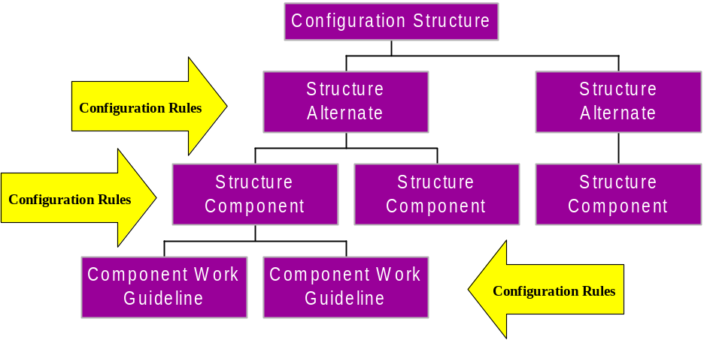
Figure 2 -- Back Office Configuration Rules, Structures

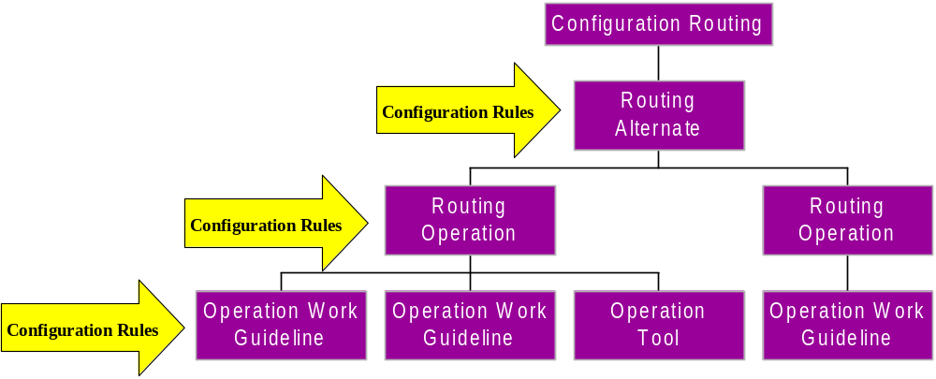
Figure 3 -- Back Office Configuration Rules, Routings
A condition is a logical expression that evaluates to either true or false – if the condition is true, then the item is selected. Condition statement can be combined using AND/OR operators to form more complex conditions. Some simple examples of conditions:
- COLOR = RED
- LENGTH GREATER THAN 10 METERS
- FINISH = WOOD AND HEIGHT LESS THAN 40 CENTIMETERS
The table below indicates the components of a selection condition statement. Each statement compares a value of one type (either entered, configuration characteristic, characteristic quantity or formula) to another value:
Table 1 -- Structure of Selection Conditions in Back Office Rules
Logical Operator | Value 1 | Relational Operator | Value 2
AND  OR | Entered Value  Characteristic Value  Characteristic Quantity  Formula | Equal To  Not Equal To  Greater Than  Less Than  Greater Than or Equal To  Less Than or Equal To | Entered Value  Characteristic Value  Characteristic Quantity  Formula
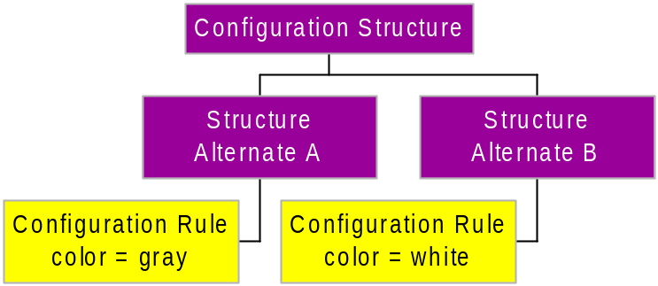
Figure 4 -- Back Office Rules, Conditions Used for Selection
Actions are used to manipulate data involved in the back office explosion logic. Actions are performed after conditions are evaluated to true. Actions answer the question, ‘Now that the element has been included, how else should it be modified?’. An action is a command to perform some data definition or manipulation. Actions come in several different varieties:
- SET – Set allows the record’s values to be modified (e.g. Qty per Assembly).
- INSERT – Insert allows an additional record (e.g. Component Part or Work Instruction) to be created.
- DECLARE – Declare allows a characteristic value and quantity to be established or updated. (e.g. Declare a new characteristic ‘OFFSET’ derived from the parent configuration). This characteristic can now be used as a variable for further rule processing.
Some simple examples of actions:
- SET Qty per Assembly = LENGTH
- SET Scrap Factor = .03
- SET Work Center No = ‘WC09’
- SET Part No = FABRICSTYLE
- INSERT Work Instruction (Work Instruction No = 1, Description = ‘Dynamic Cutting’, Work Instruction Text = CUSTOMERINSTRUCTION)
- DECLARE LEGLENGTH = HEIGHT FORMULA (HEIGHT – OFFSET)
In each of the action types, users can use different sources to supply the data values necessary for the action. Data sources allowed are the same as for conditions and include:
- Entered Values – User-entered data value.
- Characteristic Value – The value of a configuration characteristic, either the parent part’s configuration or one ‘DECLARE’d in the current scope.
- Characteristic Qty – The quantity of a configuration characteristic, either the parent part’s configuration or one ‘DECLARE’d in the current scope.
- Formula – The value returned by a formula.
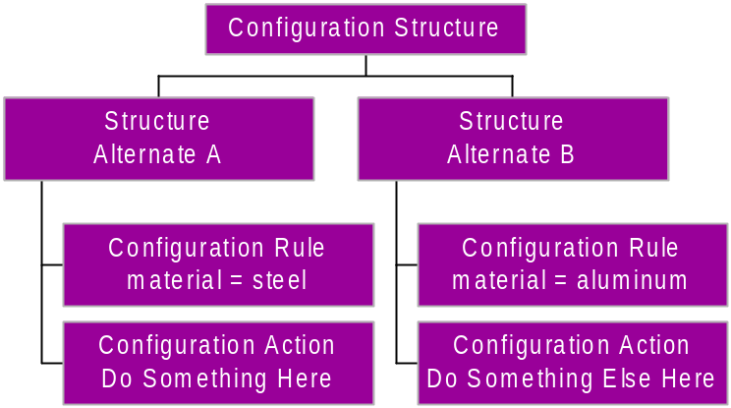
Figure 5 -- Back Office Rules, Actions used for Manipulation

Configuration Formulas
Configuration formulas allow users to express a mathematical expression to calculate numeric values used in either Conditions or Actions. A formula is defined by decomposing the mathematical expression to its basic elements: values, operators and functions. Thus a formula “WIDTH * LENGTH” is broken into three elements: 1). Value for WIDTH 2). Multiplication operator ‘*’ and 3). Value for LENGTH.
Formulas have a basic testing mechanism and a status to indicate whether they are ready for use or not in configuration rules.

Combination Tables
Combination tables are a new rule element introduced for the IFS Apps 7.5 release.
Combination tables allow users to express a value result depending on combinations of configuration factors. A combination table can be referenced in back office configuration rules in the same way as a configuration formula.
Structured like a spreadsheet, a combination table is defined by identifying the factors affecting the result, the ‘columns’ in the spreadsheet, then filling in the combinations and the associated return value. The ‘factors’ can include any type of value derived from a configuration including characteristics, characteristic quantities, formulas or even other combinations. Factors can be used more than once to handle a range of values, as shown in the example below.
Table 2 -- Example Combination Table
Characteristic  HEIGHT | Characteristic  HEIGHT | Characteristic  MATERIAL | Return Value
>0 | <= 10 | WOOD | 14
>10 | <= 20 | WOOD | 16
> 20 |  | WOOD | 20
>0 | <= 15 | STEEL | 18
>15 |  | STEEL | 24
Combination tables have a basic testing mechanism and a status to indicate whether they are ready for use or not in configuration rules. Combination tables can also specify a default return value in the event that no combination is matched

Configurations in Customer Order

General
The main CTO use cases in Quotation and Order entry are straightforward: configuration specifications must be entered for the line prior to release.
But the different customer order acquisition types drive a lot of different use cases. Since customer orders can launch supply orders and obtain supply via different acquisition types (i.e. Inventory, DOP, Shop Order, Purchase Order, etc.) the associated supply must consider the configuration of the ordered part. If a new supply order is created (e.g. Shop Order), the created order must receive information about the ordered configuration. If netting against onhand stock, the specific configuration ID is a factor in identifying the stock for picking.

Configured Quotation
Quotation lines for configured parts are created with associated configurations and CTO pricing.
Configuration change control rules:
- Any changes to the configuration after entry require price recalculation.
- Any changes to the configuration after entry require promise date recalculation, if applicable. In the case of CTO, this can require creation of an Interim Order for capable-to-promise integration.
- Changes to a configured quotation line after the ‘Planned’ state must consider the downstream impact. In general, if a quotation has been converted to a customer order line, changes to the configuration are not allowed.

Interim Order from Quotation
Users can optionally create an Interim Order for configured quotation lines via RMB methods. This creates an Interim Demand Header and associated structure of orders. This information can be used to view/review the manufacturing structure, roll up costs of the item (for use in cost plus pricing) or to manually edit the structure according to the customer’s wishes.
Interim orders are transferred with the quotation to customer order lines created during the quote-to-order process, eventually passed along to manufacturing. This is a way to indicate a specific, custom manufacturing process on a quote. The existence of the interim order overrides a standard manufacturing structure when released to manufacturing.
Configuration change control rules:
- Interim orders cannot be created or modified once the quotation line has been converted to an order line. When configuration information is ‘transferred’ to an order line, the interim order association for the quote is deleted, as it can now be accessed via the order line instead.
- Interim orders should not be created or modified after the quote line has passed the ‘Planned’ state.
- Changes to the interim order can affect the price calculation if ‘cost plus’ pricing is used.
- Changes to the interim order can affect the date promised calculation, particularly if CTP is involved.
- Changes to the configuration after an Interim Order is created means the manufacturing structure might not reflect current configuration. Users receive a warning about this situation indicating, ‘Interim order(s) exist for this quotation line. Changes to the configuration are not automatically propagated to the interim order.’
- Changes to the quantity and/or date of the quotation line affect the interim order, as it contains both quantity and date information. Users receive a warning about this situation indicating ‘Interim order(s) exist for this quotation line. Changes to the configuration are not automatically propagated to the interim order.’

Convert Quote to Order
Configuration information associated with the quotation line must be ‘transferred’ when creating a customer order line. The quote’s configuration information is passed to the new order line along with Interim Order information, if any exists. Once this conversion to an order line has occurred, no configuration or interim order activity is permitted for the quotation line.

Changing Quote After Converted to Order
In general, changes to the quote after converted to an order are limited or disallowed. Changes to a configuration, for instance, are prohibited. The system prohibits creation of any interim orders after the quote has been converted to an order. Interim orders are removed from the quote usage (detached from the quote) at the time the quote configuration is transferred to the order.

Configured Order
Configured order lines are created with associated configuration specifications and associated CTO pricing. It is important to understand there are several states during entry of a configured order line (note: this model is true of all configuration entry situations):
- Order line created for configured part, but no configuration attached.
- Order line created, invalid configuration entered, not yet attached.
- Order line created with valid configuration attached.
The last ‘state’ must be achieved before any further processing of the order line takes place.
Configuration change control rules:
- Any changes to the configuration after entry require price recalculation for the order line.
- Any changes to the configuration after entry require promise date recalculation, if applicable (e.g. CTP promise dates). In the case of CTO, this can require creation/re-creation of an Interim Order for capable-to-promise integration (2001b CBS IID).
- Changes to a configured quotation line after the ‘Planned’ state must consider the downstream impact. More on this in the ‘Release Customer Order Line’ use case section.

Interim Order from Customer Order
Users can optionally create an Interim Order for configured quotation lines via RMB methods. This creates an Interim Demand Header and associated structure of orders. This information can be used to view/review the manufacturing structure, roll up costs of the item (potentially for use in cost plus pricing) or to manually edit the structure according to the customer’s wishes.
Interim orders provide a way to indicate a specific, custom manufacturing process on an order. The existence of the interim order overrides a standard manufacturing structure when released to manufacturing.
Configuration change control rules:
- Interim orders should not be created or modified after the order has passed the ‘Planned’ state.
- Changes to the interim order can affect the price calculation if ‘cost plus’ pricing is used.
- Changes to the interim order can affect the date promised calculation, particularly if CTP is involved.
- Changes to the configuration after an Interim Order is created means the manufacturing structure might not reflect current configuration. Users should receive a warning about this situation indicating, ‘Interim order(s) exist for this order line. Changes to the configuration are not automatically propagated to the interim order.’
- Changes to the quantity and/or date of the order line affect the interim order, as it contains both quantity and date information. Users should receive a warning about this situation indicating ‘Interim order(s) exist for this order line. Changes to the configuration are not automatically propagated to the interim order.’

Release Customer Order Line
At the time configured customer order lines are released, a valid configuration must accompany the order line. The main issues to consider here are the variety of acquisition modes that can be utilized for a configured part.
Table 3 -- Order Acquisition Modes
Acquisition Mode | CTO Description | Change Control Comment
Inventory Order | Configured goods must be reserved from inventory. Configuration must match. | Cannot change configuration if reservation exists.
Shop Order | Transfer configuration information to shop order. Cannot use shop orders if manufacturing involves multi-level configuration structures. | Cannot change configuration once the order is started.
Purchase Order Transit | Customer’s configuration transferred to purchasing for outsource of configured item. Purchase receipt of configured item must pass configuration to inventory and any resulting reservation. | Cannot change configuration. Not a flexible option.
Purchase Order Direct | Customer’s configuration transferred to purchasing for outsource of configured item. Purchase receipt involves only a confirmation of shipment, no goods movement. | Cannot change configuration. Not a flexible option.
Package | Package parts and this acquisition mode are not supported for configured parts (or as package part components) as design does not support this.
Internal Purchase Transit | Customer’s configuration transferred to purchasing, then matching customer order for another internal site. Purchase receipt of configured item must pass configuration to inventory and any resulting reservation. | Same as Purchase Order Transit, with one additional complexity of adjusting internal customer order.
Internal Purchase Direct | Customer’s configuration transferred to purchasing, then matching customer order for another internal site. Purchase receipt involves only a confirmation of shipment, no goods movement. | Same as Internal Purchase Direct.
DOP Order | The required acquisition mode for DOP parts, can be either ‘Automatic’ (DOP created) or ‘Manual’ (DOP created later). If DOP automatically created, configuration must be transferred. If ‘Manual’, then DOP must match customer’s configuration. | Changes allowed up until DOP orders are started.
Not Decided | This acquisition mode is not allowed for configured parts.
Plant Design | This acquisition mode not allowed for configured parts.
Sales Quotation | This acquisition mode not allowed for configured parts.

Configurations in Interim Order Structure

General
Interim orders provide a place to store a manufacturing structure without releasing it for execution. Be aware the Interim Order structure is not used solely to support configured parts, but also is now used as a general pegging structure to support MRO Work Scope Execution and Multi-Level Availability Check functionalities. Interim orders are designed to provide a utility for evaluating manufacturing structures and routings for a configured part for purposes of testing configuration rules, cost rollup and ‘custom’ editing in the course of a customer quotation or order.

Interim Demand Head
Interim demand head instances can be created in two basic CTO use cases: 1). User-entered or 2). Created for a customer quotation or order. In either case, interim orders can be created only for configured parts.
Interim Demand Head rules:
- Creation of an interim demand head record automatically creates a top level interim order supply record.
- Upon ‘Evaluation’ of the interim head, all interim orders and associated details are removed and re-created. In this case, the configuration attached to the interim demand head must be transferred to the top level interim order.
- Cannot change configuration on interim demand head if interim demand head is associated with a Quotation or Order.

Interim Order Supply
Interim Order Supply instances can be created from either the top-level interim demand head (system maintained) or by the creation of an Interim Order Demand record (also system maintained), representing either a component or sub-assembly order. These orders can be for either configured or non-configured parts.
Interim Order Supply rules:
- Users cannot manually create an interim order supply record. They cannot create or edit a configuration, only view.
- Configurations are created and changed for the interim order supply record via actions take on the Interim Demand Head or Interim Order Demand records. No manual maintenance of the configuration occurs here.

Interim Order Demand
Interim Order Demand represents the components required of an interim order where the order represents either a top-level assembly or sub-assembly. Configured demand records can be created here either automatically as a result of the configuration evaluation process, or manually by the user. Configurations can be created and edited here, also viewed.
Interim Order Demand rules:
- Users can create new configurations and usages for configured interim order demand records.
- Users can edit existing configurations.
- Whenever a configuration is created or changed for an interim order demand record, the associated system-maintained interim order supply record must receive the new configuration. The ConfigSpecUsage LU must send a message to the InterimOrderDemand LU indicating the configuration has been changed. InterimOrderDemand logic must then either ‘transfer’ or update the configuration to the associated InterimOrderSupply record’s ConfigSpecUsage.
Changes to the configuration for a component could imply a change to the BOM. However, logic to support a ‘re-explosion’ is offered in the App7 release so long as the DOP orders have not yet reached a Started state (Started for Shop Orders, Released for Purchase Orders).

Configurations in DOP

General
DOP is intended to be the primary manufacturing execution system for Configure-to-Order manufacturing use cases. The reason for this is the need for an integrated, pegged manufacturing structure identifying all the required production steps for the customer order. As configured items are typically custom or one-time orders, it’s important in CTO to build or buy only what is exactly required.
Variations in use cases come from:
- Multi-level configuration – If multiple level configuration structures are used for a part, then DOP is the only means by which it can be manufactured due to the requirement for pegging. This means both parent and components can be configured, thus configured DOP demands and associated orders must be managed.
- Demand Source – DOPs can be created as a result of a customer order or created manually. In addition, the customer order could use an interim order as a custom manufacturing structure. In this case, the DOP structure explosion must be copied from the interim order, rather than via a configuration rules explosion.
- Netting – In order to support netting of configured items, the DOP system must recognize not just a supply based on part and contract and configuration. Thus when netting, DOP must look for orders with the same configuration in Inventory, Purchasing, Shop Order, etc.

Configured DOP Header - Basic
- DOP header is created with associated configuration. DOP header can be created automatically from customer order (with configuration) or manually. In case of a manual DOP, users must enter the configuration themselves before the DOP structure is released.
Configuration change control rules: Always in effect
- Not allowed to create structure or ‘top-level order’ until valid configuration attached to header.
Configuration change control rules: Current (more flexible, useable solution):
- Provide feature to propagate configuration changes from header to top level order, if it exists. Provide ability to re-explode configuration, to re-create lower level structures.
- Provide feature to allow customer order to propagate configuration changes to the DOP as long as structure has not been released to orders.
Configuration change control rules: Future
- Provide features to allow customer order configuration changes to be ‘diffed’. Side-by-side comparison of current structure and structure that would be used if configuration change were accepted. Provide features to propogate indicated changes down throughout execution orders (including shop orders, purchase orders, etc.). Provide ability to detect if changes effect any execution that has already occurred (orders reported, operations completed) versus work that has not yet occurred.

Configured DOP Header – No Interim Order
This case addresses a DOP header created either manually or from customer order with no associated interim order. The issue here is the choices for creating the DOP structure. When creating the DOP structure, users can exercise a number of choices to build the structure – either:
- Create it from manufacturing standards using configuration structure explosion logic.
- Copy it from another DOP.
- Simply create a top-level DOP order and manually manage the DOP structure below using a combination of manual edits, exploding branches of the structure, etc.
All of these choices are valid and essentially no different from the current DOP implementation. The only variation here is that configuration structure evaluation logic must be used rather than standard product structures.
Note that when using the configuration evaluation logic a different alternate can be selected based on the configuration characteristics. Conditions can be attached to structure and routing alternates. For example: All configurations with LENGTH < 10 might use Alternate ‘*’, while any with LENGTH >= 10 use Alternate ‘1’. Since DOP keeps a reference to the structure and routing revision used, this can be misleading for the user.

Configured DOP Header – With Interim Order
This use case addresses DOP headers created from customer order where an interim order exists for the customer order line at the time it is released to manufacturing. The interim demand structure represents a manufacturing structure that could have been edited in the course of the order entry process. The presence of this structure implies that it should be used, as it represents the customer’s wishes, rather than a normal structure explosion.
Key issues here are:
- Visibility of Interim Order – from DOP, users have no visibility to the presence or absence of an interim order. Messages and/or RMB terminology should make clear that an interim order is to be used as the source of the manufacturing structure. Users can choose to ignore the interim order when creating a structure, but they must receive warnings indicating this.
- Interim Order and DOP state – Once a DOP structure has been created, the interim order is no longer necessary and should be removed from the configuration usage for the DOP header. At the time the DOP reaches the ‘Unreleased’ state (DOP order(s) have been created), the interim order should be deleted. The interim order information is lost at this point.
The choices for creating DOP order structures must behave somewhat differently if an interim order is attached to the DOP header’s configuration usage. Regardless of how the top-level DOP order is created, it must receive a configuration consistent with the DOP header’s configuration. The RMB options:
- Create DOP Structure dialog: Create from BOM – This choice does not really make sense for an interim order situation. This choice should perhaps be disabled, or modified in some way to indicate to the user, ‘Create from Interim Order’.
- Create DOP Structure dialog: Copy from other DOP – This choice remains in place. However, if an interim order exists, it is important that users receive a warning if they choose this option. Something like, ‘This action will override the Interim Order structure associated with the demand order! Continue? Yes/No’.
- Create Structure RMB – This means the structure is created from the BOM (manufacturing standards configuration structure) if no interim order is present, but copy from the Interim Order if one is present. The RMB menu terminology and message varies depending on the situation to explain the source of the structure.
- Create Top Order RMB – This means a top level order is created for the DOP without a structure below it. If an interim order exists, users should receive a warning if they choose this option.
Note that the DOP choice for ‘Structure Depth’ has no bearing on the depth of the DOP structure when created from an Interim Order. The interim orders are simply copied as DOP orders. Interim order explosion (from configuration structure) always blows through DOP parts or configured parts.

Configured DOP Order - General
DOP orders can deal with configured parts as a result of a top-level configured DOP header or as a result of a configured component or sub-assembly (in the case of multi-level configurations). Keys issues here:
- Top-level Order – The top level DOP order is created with the same configuration as the DOP header. This is controlled by the server methods (‘create structure’, etc.) discussed above. Users should be able to view, but not edit this configuration.
- Other DOP Orders – Configured parts can be handled at any number of levels below provided the parent part is configured. In other words, only configured parents can have configured children. Configured parts and their associated configurations can be created either automatically, as a result of running the configuration explosion logic, or manually by the user. The configuration dialog is available to create, edit and view configurations for these orders.
Configuration change control rules:
- Cannot change the configuration for the top-level order (parent order id = 0) if Demand Source is other than Invent Order.

Configured DOP Order – Pegged Orders
When DOP creates pegged orders of different types (i.e. Shop Orders, Purchase Requisitions and Purchase Orders), it must transfer configuration information to those orders. In addition, change control measures must be in place to coordinate any changes to configuration information.
Configured DOP Pegged Order Rules:
- When creating pegged Shop Orders, the configuration usage associated with the DOP order are transferred to the newly created shop order.
- When creating pegged Purchase Requisition lines, the configuration usage associated with the DOP order are transferred to the newly created purchase requisition line.
- When creating pegged Purchase Order lines, the configuration usage associated with the DOP order are transferred to the newly created purchase order line.
Configuration Change Control Rules:
- Configurations cannot be edited by Shop Orders pegged to DOP orders. Logic is such that a change to the configuration sends a message to shop order asking whether this is acceptable. Shop Order logic receiving this message determines if this is a shop order pegged to a DOP order. If so, configuration change is not permitted.
- Purchasing does not provide means to edit configurations on configured requisitions or purchase orders.

Configured DOP Order - Netting
DOP provides features for ‘netting’ a required part against existing supply sources such as inventory, supply within the same DOP (either shop orders or purchase orders) or from a different DOP (again, shop or purchase supply). For configured parts, the application considers the configuration of these supply sources. But be careful here! ‘Consider’ does not necessarily mean the configuration to be netted must match exactly. The basic concept is:
- Any ‘automatic’ netting must match required configuration with the supply’s configuration exactly (meaning the same configuration id).
- Manual netting against different configurations is allowed, with a warning to the user. The client provided information indicating whether configuration is an exact match or not (preferably as a queryable element in the LOVs).
This means the various ‘nettable’ supply sources in DOP includes the supply’s configuration id as part of the criteria for automatic netting, and a consideration in manual netting. Supply sources can include:
- DOP Orders – In general, netting against DOP orders (either same DOP or other) is handled through the abstraction of the DOP order, regardless if it’s a shop order, purchase req or purchase order. Thus DOP must provide information about the configuration of the DOP order.
- For manual netting, LOVs and views describing the supply source include configuration information. This configuration correlates to the configuration on the individual supply sources described below:
  - DOP Shop Orders – Shop Order provides configuration information for netting.
  - DOP Purchase Requisitions – Purchase requisitions provide configuration information for netting.
  - DOP Purchase Orders – Purchase orders provide configuration information for netting.

Configurations in Shop Order

General
Important use case variations in configuration management in Shop Order occur according to the source of the configuration information: from Customer Order? From DOP? Entered manually? The other important variation is whether or not an Interim Order is involved in the source demand order. Much like DOP, if interim orders are involved, material allocations are created from the interim order, not from the standard product structure. If entered manually, then re-useable explosion logic is utilized to evaluate the configuration and return the appropriate set of materials and operations.

Configured Shop Requisition
Shop requisitions do not support configured parts and configurations. Configured parts are not allowed on shop requisitions.

Configured Shop Order
Configured shop orders can be created in a variety of ways:
- From a configured DOP – this is perhaps the most likely CTO use case. Configuration accompanies shop order creation.
- From a configured customer order using acquisition mode ‘Shop Order’. This is a quite likely use case. Configuration accompanies shop order creation.
- From a configured customer order where an interim order is involved. Same as above, but explosion logic uses the interim order structure when defining materials and operations, not the BOM. Configuration accompanies shop order creation.
- Manually entered – This is allowed as long as the configuration structure is not a multi-level structure (having configured components). Multi-level configurations are only allowed for DOP-pegged shop orders. Users create the configuration using the configuration dialog.
Configuration change control rules:
- Users cannot create or edit a configuration if the order is created from a demand source such as DOP or Customer Order. Changes to the configuration must be handled from the source demand order. In all cases below, configuration changes must be enforced by a message from the source indicating that the configuration is changed, will be replicated to the supplying shop order. Shop Order then determines if this is allowed or not.
- The status of the shop order cannot advance past the ‘Planned’ state (to anything: Released, Reserved, Parked, etc.) without first entering a valid configuration for the order. ‘Cancel’ is the exception here, as it deletes the order.
- The system default for the initial state of the shop order does not apply for configured parts. Configured orders always start out at the ‘Planned’ state. This rule is used to insure a valid configuration is attached prior to any further processing on the order.
- Configurations cannot be edited once the order has advanced past the ‘Started’ state. Configurations can be edited in the ‘Parked’ state. RMB methods for editing/viewing are enabled/disabled appropriately based on these restrictions.
In order to determine the material and operations for a configured shop order, the configuration must be known. As in other configuration data-entry cases, this creates a ‘sub-state’ for the order as follows:
- Configured shop order created, configuration not yet entered.
- Configured shop order created, valid configuration attached.
- Configured shop order created, materials/operations determined by configured explosion logic.
Unlike standard shop orders, the materials/operations cannot be determined until after the configuration is created. Thus explosion logic is run manually by the user after the configuration is entered, rather than at the time the order is created. This RMB is made available while the order is at the status ‘Planned’ or ‘Parked’ while a valid configuration is attached. Users are prompted ‘Do you want to update materials/operations? Yes/No’ after returning from the configuration entry dialog. Once the order has been started, users are not able to re-explode the materials and operations.
Multi-level configurations cannot be handled by shop order unless the demand source for the order is DOP. Upon creation of a shop order that is not a DOP order, users receive an error if trying to use a multi-level configuration part. Multi-level configuration is determined by the presence of configured components in the configuration structure.
Shop Order reports describing the part to be built display the relevant (display) characteristics of the configuration to be built.

Configured Shop Material Allocations
A configured material allocation record indicates a multi-level configuration structure. This is permitted only if DOP is the demand source for the shop order. Insert logic must prevent creation of a multi-level configured shop order except for in the DOP case.
Configuration rules:
- For configured allocation records created via DOP, user can view the configuration details via RMBs to the configuration dialog. No editing is allowed.
- Users cannot edit the configuration – this is controlled via the DOP source. Shop Material Allocation receive this message and determine whether or not such a change is allowed.
- Reservations for this part consider the configuration of the parts in inventory. Automatic reservations or issues, including backflush, can never issue inventory unless the configurations match exactly (Configuration Id identical to that in inventory).
- Manual reservations and issues present users with information about the configurations in inventory. I.e. Exact matching configuration versus others. In general, DOP pegging (simultaneous receipt and reservation) to the shop order material is the expected use case for configured material. Like with other DOP pegged materials, reservations are created for the DOP shop order immediately upon receipt of the configured component from purchasing or manufacturing.
- Shop order report(s) display relevant (display) characteristics for the configured component of material allocations.

Configured Shop Order Split
When configured shop orders are split, the configuration for the original shop order is be transferred to the new shop order.

Configured Shop Order Merge
Configured shop orders cannot be merged unless they feature identical configurations. Two checks made:
- When merging, configurations must be attached to each of the shop orders involved.
- When merging, the configuration of each ‘merged’ shop order must be identical to the configuration of the ‘prime’ shop order. If any are different, an error is raised.

Configurations in Purchasing

General
Purchasing supports configurations only when created as a result of a higher level demand source such as Customer Order (acquisition types) or DOP pegged orders. Users cannot manually create purchase requisitions or orders for configured items. But the configuration management cases still provide continuity, passing the configuration information from reqs to orders to receipt of inventory.

Configured Purchase Requisition
Purchase requisitions can be created from DOP or Customer Order for configured parts. Configured purchase requisition lines without these demand sources should not be allowed.
Configuration Change Control Rules:
- Users are allowed to view, but not create or edit configurations from the client.

Convert Configured Purchase Requisition to Purchase Order
When converting purchase requisition lines to purchase orders, the configuration information is transferred to the newly created purchase order lines.

Convert Configured Purchase Requisition to Request for Quote
Configured parts are not supported in Quote Request.

Configured Purchase Order
Configured purchase orders can only be created from higher level demand sources such as DOP or Customer Order (via acquisition types). Configured purchase order lines are not permitted unless such a demand source is involved.
Configuration rules:
- Users can view configurations, but not create or edit the configurations, as these come from the demand source (such as DOP order).
- Purchase order reports display the relevant configuration characteristics for configured purchase order lines.

Receive Configured Purchase Order
When receiving configured goods from a Purchase Order, users can view, but not edit, the configuration associated with the purchase order line.
At the time goods are received into an inventory location, the configuration for the purchase order line is transferred to the inventory part location.

CTO Design Topics

Creating Configurations and Uniqueness in Configuration IDs
When configurations are created, the application has features to insure each saved configuration is unique. In short, when configurations are entered, the application makes efforts to insure no duplicate configuration (same set of configuration values) exists already. This is an important concept to understand, sometimes controversial, with some expanded consequences. Implementing this concept has led to some coding complications during configuration entry that should be thoroughly understood by anyone attempting modifications.
A brief review of the application steps:
- Users create a new configuration, receive a new Configuration ID. Configurations always reference the currently effective (as of SYSDATE) base part specification revision to determine the set of characteristics and options to use. This is a common source of confusion, as CTO has no ability to build “next year’s model” configuration (or otherwise reference a future or past revision). Many feel a relevant date such as Customer Due Date or some other contextual date would make more sense.
- Status of the configuration at this point is “Incomplete”, indicating data entry is ongoing, the final configuration values are not yet known. Because a configuration is comprised of many configuration specification values (the header record) we need a user event to indicate entry is complete.
- Users indicate configuration entry is complete (e.g. Click “OK” in the configuration dialog). The configuration is saved and the status event to “Complete” the configuration is triggered.
- Before the configuration ID is saved as the reference for the usage context (i.e. Customer Order, Shop Order, etc.) an application procedure is executed to compare the values of this configuration to all existing configurations.
- If this set of configuration values is unique, then it becomes a new configuration to the database and is saved for the usage.
- If this set of configuration values already exists in the database as a valid configuration, then this configuration is discarded (deleted), and the existing configuration ID is returned instead as the one to use for the configuration usage.
As a result of the configuration “uniqueness” concept, we can now rely on the fact that two objects having the same configuration ID are in fact sharing an identical configuration. For example, as a result of this we need not compare the detailed specifications of a customer order’s configuration values to another to determine if they are the same or different. We can simply compare the integer configuration IDs. Thus if Configuration ID 2007 exists in inventory, and that matches a needed configuration, we can simply reserve or net against that configuration.
This concept represents a tradeoff in the timing of processing configuration comparison logic. We choose to implement this always at the time a configuration is saved. We add processing time to configuration entry to avoid it later at the time configurations are compared. Note that this application feature is not always desired and this application choice has been reversed at a number of customer implementations due to the nature of their business. For example, if the variance in configurations is such that customer repeats are extremely rare (no two configurations are the same), then there is really no savings in this effort. And with each order entered, the processing required of seeking out duplicate configurations increases, eventually becoming a performance burden.
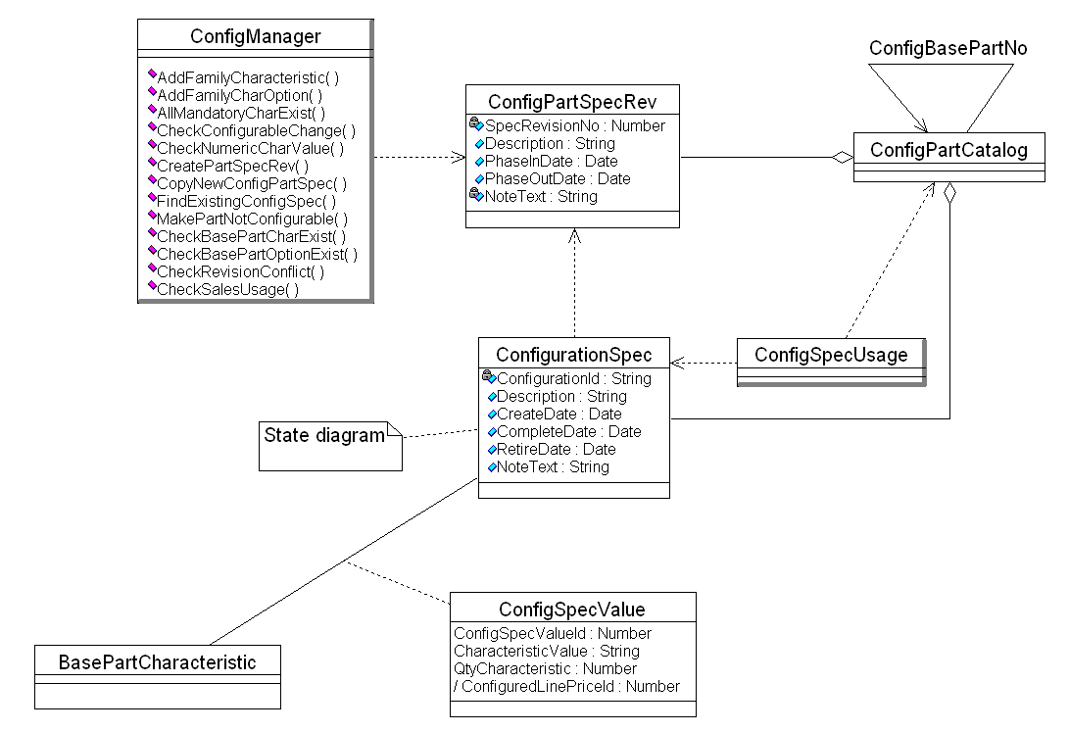
Figure 6 - Configuration Specification Model
A few tricks and tips on related topics:
- Configuration ID numbering:
  - When creating configurations, a new ConfigurationSpec is created, the ID can be seen in the Configuration dialog. However, when you exit the dialog, as described in the narration above, the Configuration ID stored in conjunction with the usage order (Customer Order, etc.) might be different due to duplicate configuration existing.
  - Be aware that when you Edit a Configuration, you are necessarily creating a new configuration and thus will once again see a new Configuration ID in the dialog. The original configuration is copied as a new one, then placed into the Incomplete state while edited. Once again, when you save you might ultimately receive yet a different configuration.
  - If you want to know the actual Configuration ID associated with a usage object, you must use the “View Configuration” option, a read-only access of the configuration dialog data. The configuration ID appearing there is the “real” one attached to the usage.
- Configuration Dialog integration with Sales Configurator
  - The Configuration Dialog is a key point, and only point, of interface between the CTO application and the SCONF application for a live data interchange while editing configurations. The web version of the configuration dialog has a similar implementation. The nature of this interface is rather complex and beyond the scope of discussion here, but a few frequently asked points follow.
  - The SCONF application saves sales rules “version” files in the IFS application database along with a record stored in the ConfigExternalData LU (CFGCHR) indicating the revision of the catalog version file that is stored. Note that sales rules catalog files are saved per Configuration Family (family of related configured products).
  - At the time the Configuration Dialog is opened, the application checks the ConfigExternalData records to determine if any sales rules exist for the product’s configuration family. If so, then the SCONF application is launched via an active-x control used by the dialog to access the Sales Configurator’s APIs. If the Sales Configurator is not installed on the client (keep in mind this is a windows client application) that you are working upon (or configured as an application shared by that client), then you will receive an error that Sales Configurator is not installed and will not be able to proceed. The CTO flow dies in this case. This is an extremely common situation for Citrix-based or Web installations (SCONF must be installed on the web server machine), particularly with the CTO Race Data related to the EASYFLEX family of products which is installed with sales rules in place. Two ways to deal with this: 1). Install Sales Conf. on the machine or 2). Delete the record from ConfigExternalData for that family and work without the sales rules.
  - Once the Configuration Dialog successfully finds the Sales Configurator application, it launches this windows application on the client machine using “Hidden Mode”. The application does not appear as a visible app on windows task bar, for instance, but can be seen as an application process called “pess.exe”. The nature of the IFS-SCONF interface is such that the API allows simulation of client clicking/mousing events in the SCONF application. You can actually witness the interface in action by starting the IFS client debug console prior to executing the configuration dialog. In this mode, the SCONF application is launched in foreground mode, and you can see the interaction consequences when data is added/changed in the entry dialog. This is an important debugging tool.
  - When the configuration is completed, the SCONF application session is ended and the Sales Professional application (pess.exe) is closed.

